REG NO: 19BCS0012

NAME: NITHISH.G

LAB 1: DATA FEEDING IN SPSS

VARIABLE VIEW:

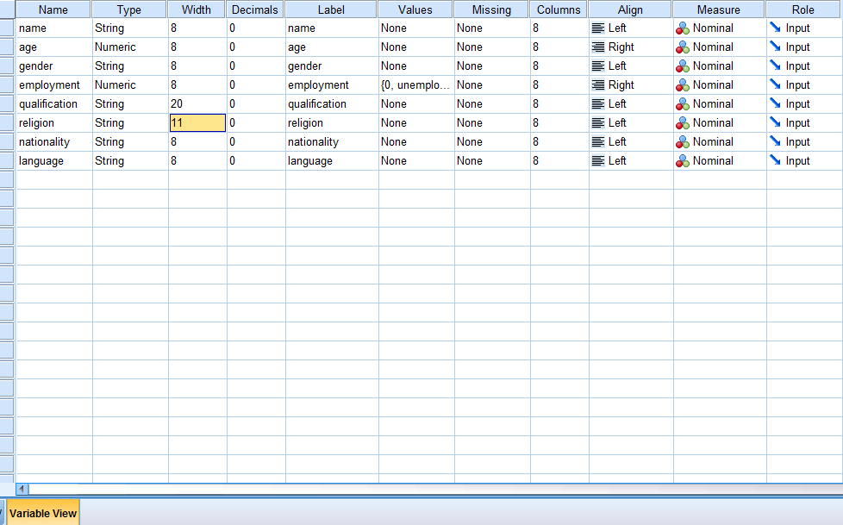

DATA VIEW:

